**Exp. 1** **Design an LED flasher**

Circuit Diagram:

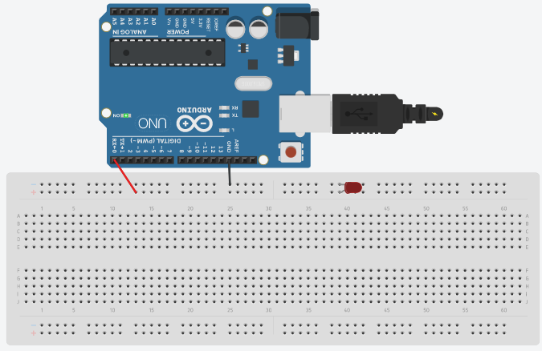

**Theory**

Concepts Used:

1. Working of Arduino UNO
2. Coding in Arduino IDE and syntax of the same
3. Working of LEDs (Light emitting diodes)
4. Making connections on a Breadboard.

Learning & Observations:

Coding in Arduino IDE: It’s a very systematical way to show how the circuit is working. Coding syntax is very similar to the coding in C language which we are being taught. I learnt the importance of delay function as the micro-controller is very fast and capable.

I observed that there are many other interesting functions, like random function is fun to use.

Arduino seems like my first step towards ROBOTICS.

Problems & Troubleshooting

I didn’t encounter any issues as it was simple to understand and perform.

Looking forward to some interesting problems related to Arduino UNO’s use.

Precautions

1. Remember to declare all the ports in use in digital input/output in the right way.
2. Check whether all your wire pieces are working correctly and all connections are good.
3. Remember to connect Negative end of device (in this case LED) to GND (ground) in Arduino Uno to ensure potential difference.

Learning Outcomes

Skills that I have acquired are sound knowledge of using Arduino UNO and slight Idea of how to utilize Arduino Uno in other scenarios.